7/13/22, 11:56 PM Untitled Diagram.drawio

<<include>>

owner

Sawariya Mobile System

View Product

Add To Cart

Registration

Log In

Order Product

Make Payment

View Order

Exchange/

cancle Order

View Profile

Create Product

Edit Product

Confirm Order

New Customer

Web Customer

Registered customer

customerr

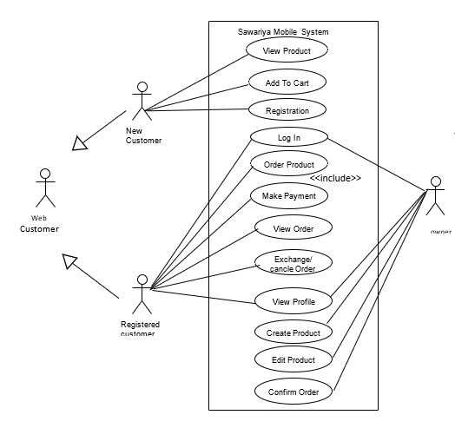

1/1